25 May 2021

Dear Colleague

We are providing an update with regards to the current COVID-19 situation and advice and guidance regarding testing and would ask that you share the information contained in this letter with your staff, parents and carers.

- The North West of England is seeing a rapid rise in cases of a new variant of COVID-19, commonly referred to as the “Indian” variant, with several large outbreaks seen in other parts of Cheshire and Merseyside. We’re trying to stop the spread of this in Halton.
- Rapid lateral flow testing is still important for picking up cases of COVID-19, but we need people who test positive or have symptoms to get a PCR test (that is sent to the lab for processing) so we can tell which variant it is. We are now asking people who are identified as contacts of someone with confirmed COVID-19 to get a PCR test too.
While the roll-out of the vaccines is progressing well, many of education staff and parents still will not have received their vaccination.

We must continue to be vigilant to prevent another wave of COVID-19 cases. I ask that you advise your staff, parents and carers that they should:

- Follow national advice and restrictions around mixing with others and do this as safely as possible. Meeting outside is still safest.
- Get your vaccination when you are invited.
- Continue twice weekly rapid testing for COVID-19. This is for families, staff and secondary school and college students. Parents of primary aged children may also choose for their children to participate in these tests using our test centres or home tests. Additional information can be found here: No symptoms COVID-19 testing (halton.gov.uk)
- Anyone with a positive rapid lateral flow test should self-isolate with their household and get a PCR test (that is sent to the lab) to confirm the result. These must be booked online at https://www.gov.uk/get-coronavirus-test
Schools should identify contacts and advise self-isolation and testing (see below) on the first positive result.
- Testing results should be reported via the NHS online reporting system. Results should also be reported to school (schools may have their own systems in place for reporting results).
- Schools should continue to report all positive cases (both rapid lateral flow tests and PCR tests) to Ann McIntyre (ann.mcintyre@halton.gov.uk ) and to the public health team (public.health@halton.gov.uk ).
- Self-isolate and get a PCR test (that goes to the lab) if you or anyone in your household gets symptoms. This can be arranged by booking a test online by visiting: https://www.gov.uk/get-coronavirus-test or calling 119.
- Remember that if you (or your child) have been in contact with someone with COVID-19, you will need to isolate for ten days, regardless of any test results you might get.
- In Halton we are advising that all identified contacts of confirmed positive cases take a PCR test (that goes to the lab). You will need to continue to isolate regardless of the result of this test. This can be arranged by booking a test online by visiting: https://www.gov.uk/get-coronavirus-test and selecting ‘My local council or health protection team has asked me to get a test, even though I do not have symptoms‘

Face coverings should still be worn in recommended circumstances. Though we are concerned about the new (“Indian”) variant of COVID-19, our overall rates of COVID-19 are currently low. This means that after half term, we will no longer be advising that secondary students wear face masks and our advice will be in line with national guidance.

We recommend that:

- Face coverings should be worn by staff and visitors in situations outside of classrooms where social distancing is not possible (for example, when moving around in corridors and communal areas).
The reintroduction of face masks for staff and students may need to be reconsidered if rates change or during the management of an outbreak.

Many thanks for your understanding.

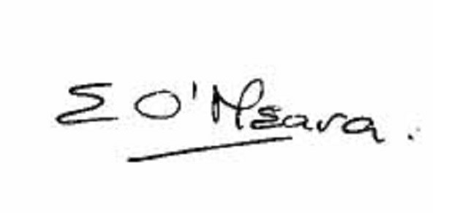

Eileen O’Meara, Director of Public Health and Health Protection
Halton Borough Council

