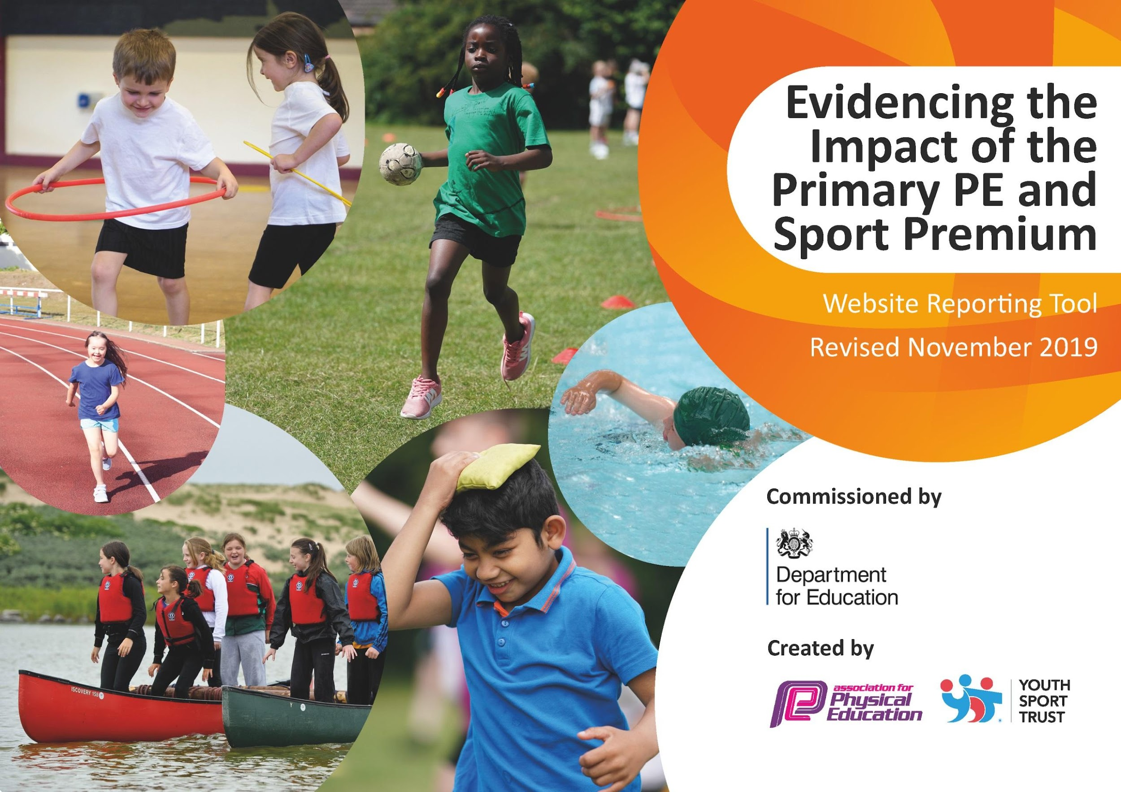
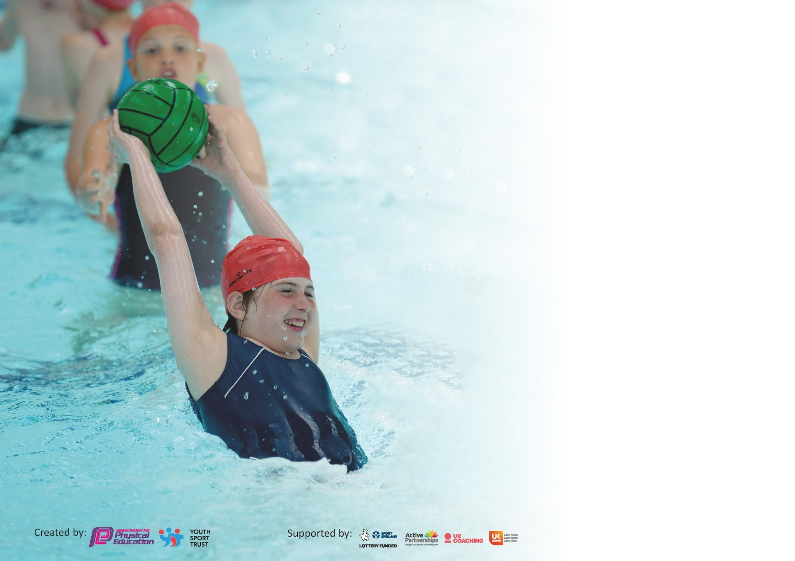

It is important that your grant is used effectively and based on school need. The Education Inspection Framework (Ofsted 2019 p64) makes clear there will be a focus on ‘whether leaders and those responsible for governors all understand their respective roles and perform these in a way that enhances the effectiveness of the school’.

Under the Quality of Education criteria (p41) inspectors consider the extent to which schools can articulate their curriculum (INTENT), construct their curriculum (IMPLEMENTATION) and demonstrate the outcomes which result (IMPACT).

To assist schools with common transferable language this template has been developed to utilise the same three headings which should make your plans easily transferable between working documents.

Schools must use the funding to make additional and sustainable improvements to the quality of Physical Education, School Sport and Physical Activity (PESSPA) they offer. This means that you should
use the Primary PE and Sport Premium to:

- Develop or add to the PESSPA activities that your school already offer
- Build capacity and capability within the school to ensure that improvements made now will benefit pupils joining the school in future years

Please visit gov.uk for the revised DfE guidance including the 5 key indicators across which schools should demonstrate an improvement. This document will help you to review your provision and to report your spend. DfE encourages schools to use this template as an effective way of meeting the reporting requirements of the Primary PE and Sport Premium.

We recommend you start by reflecting on the impact of current provision and reviewing the previous spend.

Schools are required to publish details of how they spend this funding as well as on the impact it has on pupils’ PE and sport participation and attainment by the end of the summer term or by 31st July 2020 at the latest.

We recommend regularly updating the table and publishing it on your website throughout the year. This evidences your ongoing self-evaluation of how you are using the funding to secure maximum, sustainable impact. Final copy must be posted on your website by the end of the academic year and no later than the 31st July 2020. To see an example of how to complete the table please click HERE.

Support for review and reflection - considering the 5 key indicators from DfE, what development needs are a priority for your setting and your pupils now and why? Use the space below to reflect on previous spend and key achievements and areas for development.

Key achievements to date until July 2021: | Areas for further improvement and baseline evidence of need:
- Tennis CPD (KM) Summer Term. Upon completion of course we will receive in school tennis coaching/ support  - PE curriculum being taught in double sessions due to covid/ children attending school in PE kits  - All staff using PE passport to plan and assess progress where possible due to covid.  - During school closure weekly PE was planned for but engagement was limited.  - iPads bought and staff using them to deliver PE passport  - Staff PE kits purchased to raise standards of dress during PE  - Texts sent home to parents about wearing correct PE kit  - MUGA installed  - Secured taster sessions with ABC boxing and education centre when safe.  - Links made with Jo Obiero from school games and Grace (Daily Mile coordinator) | - Clubs to resume after whit holidays (covid dependent)  - Swimming still not happening due to covid  - Raise profile of competition during summer term at school and hopefully with other schools towards the end of summer term covid dependent  - Take part in school games competitions during summer term and raise our online twitter profile.  - Ensure daily mile takes place in Summer term  - Plan school sports day (covid secure)  - Reintroduce sports leaders when safe to do so.  - When clubs reopen promote children's success in sport outside school during weekly assemblies.  - Complete survey on clubs currently attended and clubs children would like to attend  - Get children active and increase fitness after lockdown!

Meeting national curriculum requirements for swimming and water safety.
What percentage of your current Year 6 cohort swim competently, confidently and proficiently over a distance of at least 25 metres?  N.B. Even though your pupils may swim in another year please report on their attainment on leaving  primary school at the end of the summer term 2020. | 75%
What percentage of your current Year 6 cohort use a range of strokes effectively [for example, front crawl, backstroke and breaststroke]? | 50%
What percentage of your current Year 6 cohort perform safe self-rescue in different water-based situations? | 94%
Schools can choose to use the Primary PE and Sport Premium to provide additional provision for swimming but this must be for activity over and above the national curriculum requirements. Have you used it in this way? | No

Action Plan and Budget Tracking
Capture your intended annual spend against the 5 key indicators. Clarify the success criteria and evidence of impact that you intend to measure to evaluate for pupils today and for the future.

Academic Year: 2020/21 | Total fund allocated: £17297 | Date Updated:March 2021
Key indicator 1: The engagement of all pupils in regular physical activity – Chief Medical Officer guidelines recommend that primary school pupils undertake at least 30 minutes of physical activity a day in school |  |  |  | Percentage of total allocation:
 |  |  |  | 55.1%
Intent | Implementation |  | Impact
- Provide a range of activities - implementation of new extra-curricular timetable. Increase the number of clubs for children.  - A wider range of clubs need to be offered after conducting a pupil voice questionnaire (particularly in KS2).  - Funding to help disadvantaged to attend extra-curricular clubs. | - Increase range of clubs provided: gymnastics, dance, archery, speed stacking, multi sports etc |  | Not achieved due to covid. | Sustainability and suggested next steps:  Once restrictions lift, enhance extra curricular activities across KS1 and KS2.
- Engage more EYFS children in physical activity during curriculum time | EYFS outdoor provision to be improved (linking to post Ofsted action plan) | £530 | Outdoor play has been offered every day with some new equipment purchased. | Resources are limited. New bikes are needed and obstacle course resources to develop further. Possibly look at redesigning outdoor area.
- Daily Mile to be completed by each pupil | Add in an extra afternoon break time to the timetable to allow for completion of the Daily Mile |  | Most classes have accessed daily mile but not consistently each day. | Embed Daily Mile.  Have a timetable of activity at lunch times for whole school to allow for focussed sports activities.
- Develop provision for physical activity at lunchtime by; increasing the amount of playground resources to provide playground activity facilitated by MDAs. | - Sports coach part of MDA team  - Sports coach timetable of KS1 and KS2 lunchtime sporting club  - New resources purchased to be used at lunchtimes  - Sports coach to continue to recruit Y5/6 pupils to be play leaders to help deliver lunch activities to the KS1 pupils. | £9000 | Sports coach was only able to work with one bubble so did not deliver clubs across the school at lunch or recruit play leaders.  Resources bought and in use daily, hula hoops, skipping ropes and balls  MUGA installed and timetable for use in place.
Key indicator 2: The profile of PESSPA being raised across the school as a tool for whole school improvement |  |  |  | Percentage of total allocation:
 |  |  |  | 17.6 %
Intent | Implementation |  | Impact
- Quality of Education: To ensure a highly effective curriculum where all children make significant progress from their starting points. | - Sports coach employed to deliver lunchtime sports clubs to help with behaviour management/reduction of incidents.  - Continue to spend some funding on staff CPD in suggested areas (staff audit) to increase quality of teaching and learning.  - Ensure new staff know how to use PE Passport and receive relevant CPD | £2850 | New staff are using PE passport. Gaps in PE skills/ coverage due to covid.  No staff CPD delivered in person as the restrictions on visitors to school was in place. | Sustainability and suggested next steps:  Seek staff CPD in person after a staff questionnaire to identify gaps in knowledge and confidence.
- Promote physical activity outside of school and celebrate in weekly celebration assembly | - Have section of weekly celebration book for sporting achievements/awards  - Hand out leaflets for local clubs  - Allow presentations/taster sessions delivered by local clubs  - School partnership with Widnes Vikings RLFC  - Collect data termly about PE clubs attended by all students outside of school by sending questionnaire via school spider, website etc  - End of year SPOTY awards | £200 | Secured taster sessions with new local boxing club and education centre.  Partnership with Widnes Vikings continued during lockdown. | Begin to roll out SPOTY of the year next year.  Introduce parent questionnaire about physical activity outside of school.

Key indicator 3: Increased confidence, knowledge and skills of all staff in teaching PE and sport |  |  |  | Percentage of total allocation:
 |  |  |  | 13.0%
Intent | Implementation |  | Impact
- To ensure all children are participating in two hours a week of high quality PE the Quality of teaching and learning in Physical Education will be developed through staff CPD for all class teachers. | - Subject leader to attend relevant CPD courses  - Complete another staff audit in different areas of PE and arrange CPD for areas of low confidence (Lynch Sports Accelerator) |  | No CPD offered due to Covid  When not in lockdown PE taught in 2 hour blocks. | Sustainability and suggested next steps:  Ensure there are 2 hours of PE on class timetables.
- Set up PE curriculum that will be implemented and introduced to continue to improve the overall delivery and consistency of the PE provision. | - Quality and quantity of resources for lessons purchased to allow for outstanding physical education and pupil attainment  - Continue to offer CPD and support in delivering PE Passport across the school (half termly staff meeting slot)  - Purchase staff iPads for planning and delivery of PE scheme | £2259 | PE Curriculum in place but due to lockdown there will be gaps  Staff iPads bought and in use. | Audit resources to make sure that they met the needs of the curriculum.  Seek staff CPD in person after a staff questionnaire to identify gaps in knowledge and confidence.
Key indicator 4: Broader experience of a range of sports and activities offered to all pupils |  |  |  | Percentage of total allocation:
 |  |  |  | 5.8 %
Intent | Implementation |  | Impact
- Continue to offer a wider range of activities both within and outside the curriculum in order to get more pupils involved. | - Partnership with Widnes Vikings RLFC to deliver aspects of the curriculum and extra-curricular clubs  - Continue to source different providers of a range of clubs  - Listen to pupil voice to see which activities the children would like to have the opportunity to try | £1000 | Covid has prevented offering extra-curricular clubs.  Leaflets given out for clubs outside of school in the local area. | Sustainability and suggested next steps:  Meet with SGO to set out a plan for competitions.  Make links with local clubs to come and deliver taster sessions in school.

Key indicator 5: Increased participation in competitive sport |  |  |  | Percentage of total allocation:
 |  |  |  | 2.8%
Intent | Implementation |  | Impact
- Ensure intra school (within the class during curriculum time) competitions take place | - Whole School Sports Day to involve every child in competitive sport  - Use house system to create intra school league table possibly  - Share on social media when competitions happen (intra school competitions)  - PE Passport scheme allows for competitions within the units of work during curriculum time. | £ | PE passport has been implemented where possible due to school closures and internet access.  School sports day taken place in year group bubbles. | Sustainability and suggested next steps:
- Ensure that competition is accessible for all KS1 and KS2 pupils | - Apply for School Games Mark  - Share on social media when competitions happen  - Buy into School Game programme and attend competitions | £485 | School games mark not taking place this year.  Schools games mark has been suspended this year.  Children’s achievements in sport out of schools celebrated in weekly class assembly. | Apply for school games mark.  More celebration of PE on social media.
- Celebrate the more able and talented pupils | - Support them to attend more level 2 and 3 sports competitions |  | No local competitions due to covid | Buy into SG and allow for children to attend competitions.

Signed off by
Head Teacher: | Sandra Pope
Date: | 21st December 2021
Subject Leader: | Kirstie Crook
Date: | 21st December 2021
Governor: | Tammy Vickery
Date: | 21st December 2021

