Year 3
The Great Paper Caper (week 2)
Weekly Writing Tasks

Vocabulary
- alibi
- eyewitness
- investigation
- culprit
- biennial
Monday | I can create a funny poem  Read the next double page spread. Can you consider what ‘a solid alibi’ means from the context of the sentence?  alibi - a claim or piece of evidence that one was elsewhere when an act, typically a criminal one, is alleged to have taken place.  Create a story map of your ‘story’ (your alibi) Can you add place prepositions to your story map also?  Use your story map to write a (funny) poem – A Solid Alibi e.g.  It wasn’t me!  I have been too busy!  At Boy’s house I had a cup of tea,  Then I ran towards my tree  I danced around it happily  and jumped down my tunnel  to my warm home.  There I snuggled into my favourite chair  And fetched my knitting from off the floor.  Later I sat in my hairdresser’s chair  Under the dryer with my book on my lap.  I had no time for anything else in my busy day.  It wasn’t me!
Tuesday | I can write in role as the beaver detective  You need to act as a detective! Gather evidence from the illustrations so far of the bear’s antics and what the other animals have missed. Go through the book from the beginning up to ‘An investigation was launched to get to the bottom of things.’  Write a clue/piece of evidence that you have spotted (see resources).  Explore the vocabulary on the double page spread beginning, ‘An investigation was launched…’ and up to, ‘…so the tree thief could be caught’ (judge, prosecutor, detective, investigated, launched). Look carefully at the words investigation, launched, detective, judge, prosecutor (see resources.) Decide which is the correct definition and once decisions are made, to find the words in the dictionary to check the meaning.  You now need to write in role as the beaver detective to persuade the judge that something needs to be done to stop the thefts. e.g.  Dear Judge,  Today I have launched a serious investigation to ensure the tree thief is stopped. The evidence I have gathered must be shared with you immediately. This thief has followed several steps in order to steal the trees. First, he has dragged his axe into the forest. This item was large and very heavy, but the thief has managed it easily! With this axe the thief has chopped down trees and he has cut up branches. There are logs everywhere that the thief has piled together.  Something must be done to stop this as soon as possible. I have talked to many of the forest creatures and they have all agreed with me. I will not stop until I have brought the culprit to you!  Yours sincerely, Beaver Detective
Wednesday | I can write as the bear in his diary.  Read up to the picture of the bear hiding guiltily behind the tree. Discuss each of the things the bear has done on this page (present perfect): e.g. has folded several paper aeroplanes, has tried to fly them, watched as they have fallen to the ground, has grown more and more frustrated and angry, has hidden behind a tree as he realises that the other characters are investigating.  Fold a simple paper aeroplane (see instructions in resources.) Then practise the present perfect tense and prepositions by writing in the first person as the bear, ‘I have……’ Write your sentence onto your paper aeroplane and either fly it to a friend to read or scrunch it up like the bear did and throw it to a friend instead.
Thursday | I can write as the bear in his diary.  e.g.  Dear Diary,  What a time it has been! I have tried and tried to make a good paper aeroplane to enter the competition because I really want to win. Sadly I have had no luck so far. I have followed the instructions carefully. Each time I have made a paper aeroplane I have cut and folded sheets of paper with great care but not once has it worked! Every instruction has been followed. I have pressed all the edges down carefully so that it is neat and tidy but it has made no difference!  Every time I have made a plane I have tried it out but just watched each one hit the ground in a crumpled mess. I have wondered where I am going wrong but eventually I have just got really cross about it.  I have kept trying because I am determined to win the competition. I know I am using up a lot of wood but I would love to win.
Friday | I can write an evidence sheet for what the beaver saw  Read to the scene of the big green paper machine. Discuss the meanings of the words ‘eyewitness’ and ‘culprit.’  What can beaver see through the window? Plan ideas for three paragraphs to describe the scene i.e. what the beaver can see in the centre of the room, on the walls, and on the desk. Try to use of prepositions. Record on a grid (see resources).  The 3 columns in the table represent 3 paragraphs of information. You will need to consider a new paragraph for a change of location.  You will not believe what I have seen today as I peered through the window of the bear’s workshop. In the middle of the floor was a huge, green, noisy machine. Puffing and panting heavily, bear was pushing a whole tree into this machine, and out of the other end came sheet after sheet of beautiful, neatly cut white paper. There were handles and knobs, dials and switches on the sides of the machine, and two narrow chimneys which carried some, but not all, of the smoke out and into the air.  Up above I saw… Then I turned around and examined the desk…
See following pages for resources.

Monday

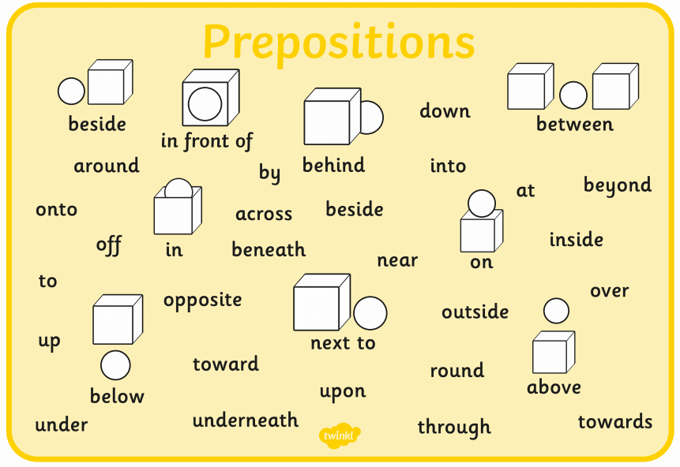
Tuesday

Clue 1
Clue 2
Clue 3
Clue 4

Match the definitions
investigation | launched | detective | judge | prosecutor

A person whose job it is to solve crimes. | To study by looking closely and questioning. | To get going, to start something. | A lawyer who argues in court that a person is guilty. | A person who is on control of a court of law.
Wednesday
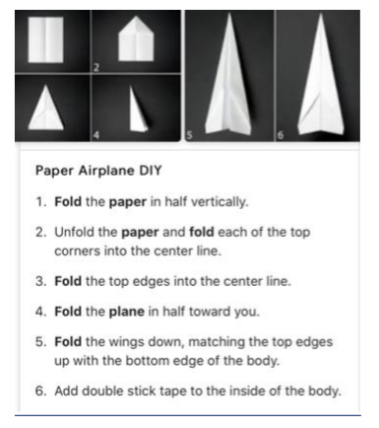

Thursday

Centre of the room | On the walls | On the desk
Friday

