Dear Parents and Carers,

From Wednesday 6th January, your child is required to work remotely from home until they return to school. Most of the pupils in the school have already been using Google Classrooms and know their login details. If you are unsure of your details then please ring the school office.
Outlined below are the details you will need to access daily remote learning.
Daily Remote Learning
As children are all expected to access their school work every day, all remote learning will take place on Google Classrooms. This will act as a virtual classroom and we will be teaching the same curriculum as we would have been teaching in class. Teachers will be available to support children and give feedback within their Google Classroom from 8.50am -3.15pm.

Please find below a set of instructions for children’s teaching and learning each day:

- All children will need to log on to Google Classroom, using the app or the web page, by 8.50am.

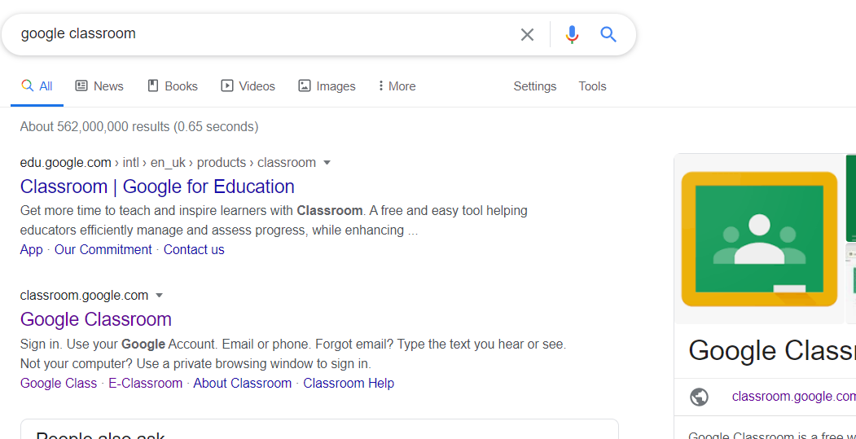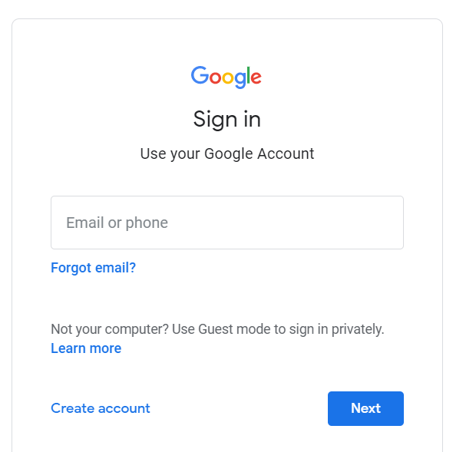

2) They will then need to click on their classroom.
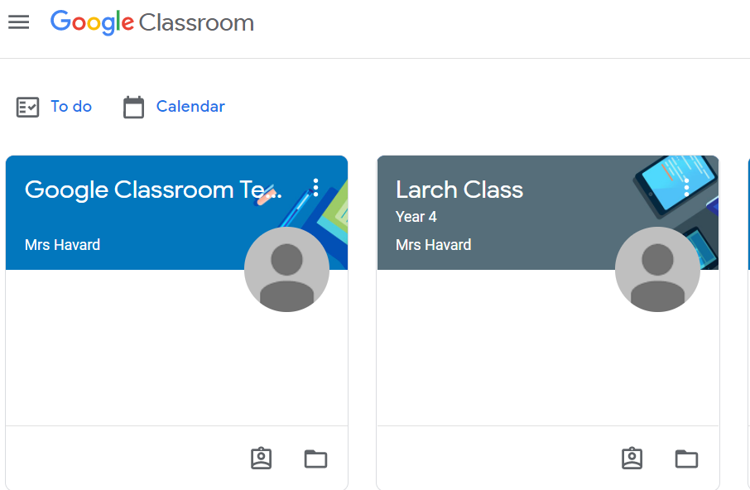

3) Then write a reply to the teacher’s comment as their class register for the morning.
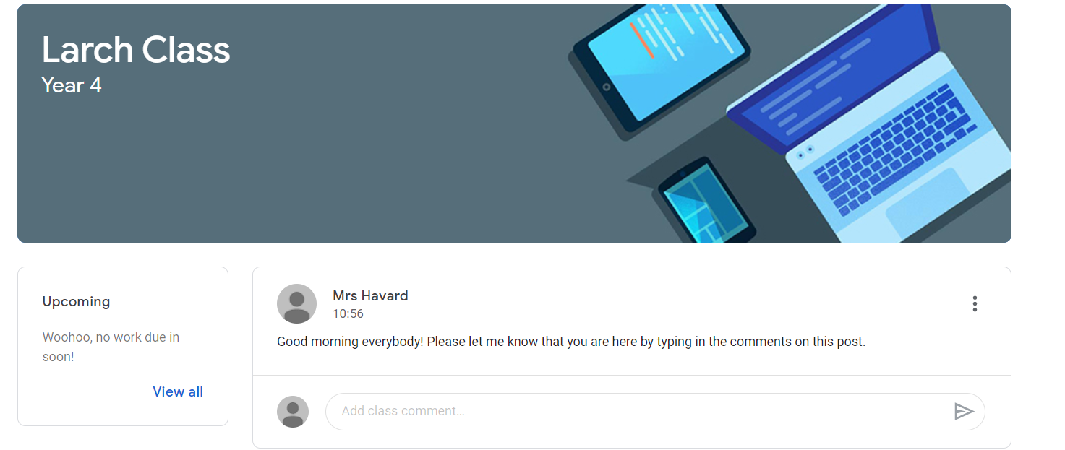
4) Work can then be seen either through the class stream
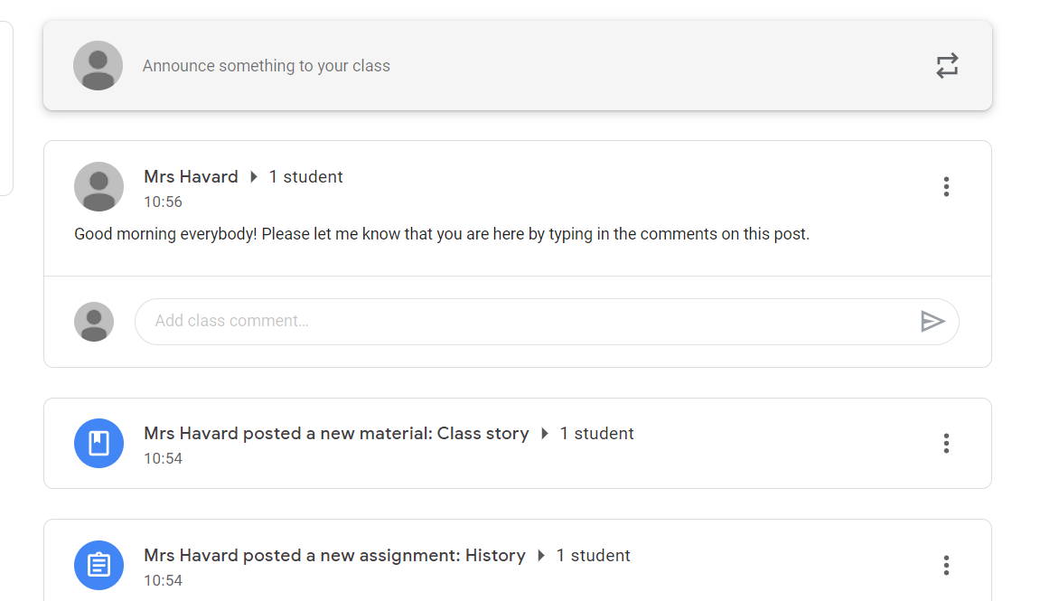
Or by clicking on the class work tab where lessons and all of the resources including teacher videos, links and activities will be posted. Each morning, there will also be a summary plan available detailing the lessons for that day.
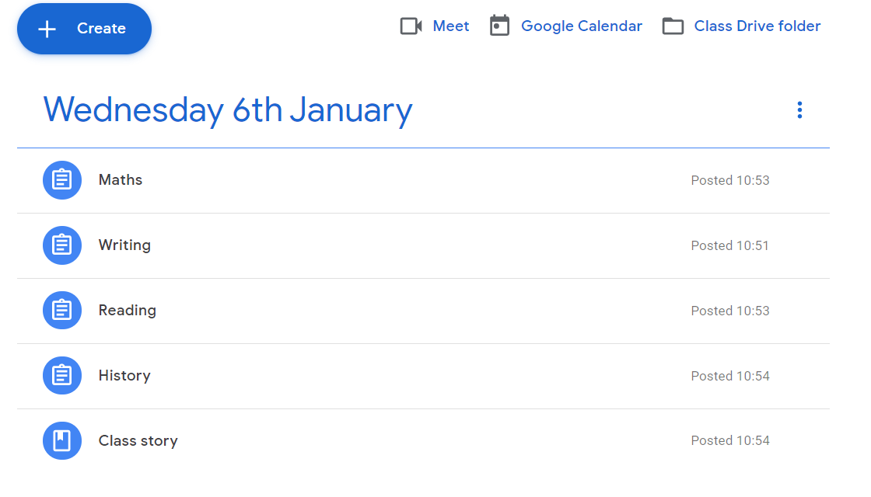

5) Work will need to be submitted or ‘Handed in’ via Google Classroom either by completing it within the classroom (Google docs, quizzes etc) or by completing the work in your book and submitting a photograph of the work. Teachers will then be able to provide feedback or further teaching based on children’s understanding.
During the day, teachers will be available to support and answer questions sent privately or via the class stream on Google Classroom.
There will also be a daily live video catch-up for each class. Class teachers will inform you of the time.
Don’t forget to watch our ‘how to’ videos on the Westfield Webpage under the ‘REMOTE LEARNING’ tab for support and teacher’s emails are still available for contacting them directly.
If you are unable to login please contact school. If we can see that you have not logged in, then school will contact you.

